Phonics Activities –

* Rhythm and Rhyme- Can you find items that rhyme in your house – clock and sock, top and lollipop etc
* Recap the sounds we have learnt in school so far using Jolly phonics songs- <https://www.youtube.com/watch?v=Y03uiPd-JTc>
* Can you find things in your house that begin with the same sound? (alliteration)

Physical Development- looking after myself.

* Practise putting your uniform on by yourself.
* Practise putting your coat on and doing the zip
* Can you go to the toilet yourself? Can you wash and dry your hands. Do you know how to blow your nose?
* Do you have a good bedtime routine? Bath Book Bed.



Getting ready for F2!

Listed are some activities you can do with your child at home to help them get ready for Foundation 2 ☺

If your child can not yet do anything on this sheet then practise during your time at home and they will be in the best position to start F2 in September ☺

Personal, social and emotional development

* Can you practise how to calm yourself down when you are upset or angry- e.g. deep breaths, counting, distracting myself
* Practise tidying things away when you are asked- who can tidy up the quickest? Where do they things live?

Physical development- moving

* Can you run safely and move in different ways- hopping, jumping, skipping etc.
* Develop your strong hand muscles – using YouTube videos such as- dough disco and songs with playdough

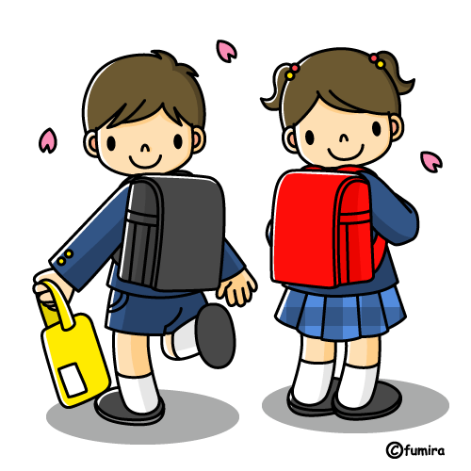

Literacy Activities

* Practise writing some letters/all of the letters in your name.
* Read your favourite stories and read them to adults without being able to read decode them.
* Tell your grown up about the characters, setting and main events in a story.
* Practise holding a book the correct way up and turn the pages one my own.

Maths Activities

* Practice counting out loud to 10.
* Count objects to 10 independently, 1 by 1 saying how many you have.
* Begin to represent numbers using marks on paper.
* Gain/develop knowledge of simple 2D shapes – circle, triangle, square, rectangle and can find them in the environment- shape hunt on your walk home – windows are rectangles etc.
* BBC iPlayer Number blocks is great ☺